**Ceramics**

The term “ceramic” comes from (Gk. Keramos- burnt matter) indicating that desirable properties of these materials are generally achieved through a high-temperature heat treatment process called firing. Ceramics consist of a combination of non –metallic substances mostly silicates and metal oxides. It is used to indicate refractories, glass, enamels, porcelain, bricks and abrasive materials. For example, some of the typical ceramic materials include aluminum oxide, silicon dioxide, silicon carbide, silicon nitride and, also, the traditional ceramics are those composed of clay minerals as well as cement and glass. The chemical combination of different metallic and non-metallic elements gives rise to ceramic materials with a variety of properties. They could withstand a temperature of 1500 to 2000 0 C, but a particular application may require the metals to withstand the temperature up to 5000 0 C.

For mechanical behavior, ceramic materials are relatively stiff and strong, very hard, brittle, highly susceptible to fracture, higher stability, and higher melting points. Most of these are insulators like other covalent materials. Some of the refractory materials are quite stable and are thus used as structural materials in structures where resistance to high temperature and oxidation are essential, as in furnaces for steel making and as glass making. About optical characteristics, Ceramics may be transparent, translucent, or opaque, and some of the oxide ceramics (e.g.,Fe3O4) exhibit magnetic behavior. These new materials affect our lives; electronic, computer, communication, aerospace and a host of other industries rely on their use.

Classification of ceramic materials on the basis of application

1. *Glasses* - products of fusion rapidly cooled to a rigid condition without crystallization.

They are noncrystalline silicates that contain other oxides. Optical transparency is the most desirable properties of these materials. The most common uses for these materials are as ovenware, tableware, oven windows because of their strength and excellent resistance to thermal shock. They also serve as electrical insulators and as substrates for printed circuit boards and heat exchangers and regenerators.

2. *Clay products*- structural clay products, whitewares

Clay is the principal component of the whitewares and structural clay products. Structural clay products include building bricks, tiles-applications in which structural integrity is essential. In the whiteware ceramics group are porcelain, pottery, china and sanitary ware. Feldspar and quartz may be added which influence the changes that occur during firing. Fireclays are hydrated aluminosilicates of composition Al2O3.2SiO2.2H2O.

3. *Refractories* – fire clay, silica, basic, special materials :

The materials that are employed at elevated temperatures and often in reactive environments. By composition and application, the four main subdivisions are fireclay, silica, basic and special. Typical applications include furnace linings for metal refining, glass manufacturing, metallurgical heat treatment and power generation.

*3a. Acid refractories*

They consist of mostly acidic materials like alumina (Al2O3) and silica (SiO2). They are not attacked or affected by acidic materials, but easily affected by basic materials. They include substances such as silica, alumina, and fire clay brick refractories. Fireclay bricks are used in furnace construction to confine hot atmosphere and to insulate structures from excessive temperatures thermally.

*3b. Neutral refractories*

These are used in areas where slags and atmosphere are either acidic or basic and are chemically stable to both acids and bases. The principal raw materials belong to but are not confined to, the M2O3 group. The typical examples of these materials are alumina (Al2O3), chromia (Cr2O3) and carbon.

*3c. Basic refractories*

The refractories that are rich in periclase, or magnesia (MgO) are termed basic; they may also contain calcium, chromium, and iron compounds. These are used in areas where slags and atmosphere are basic; they are stable to alkaline materials but could react with acids. The steelmaking process used artificial periclase (roasted magnesite) as a lining material for the furnace.

4. *Abrasive materials* – metal oxides and nitrides:

The abrasives being hard and tough are used to cut, grind and polish other softer materials. Diamond, SiC, Tungsten carbide are typical examples. The abrasives may be employed in the form of loose grains, bonded to an abrasive wheel or coated on paper or fabric, used for sharpening knives and polishing wooden surfaces.

5. *Cement* – Portland cement:

When mixed with water, inorganic cement forms a paste that is capable of assuming just about any desired shape. The subsequent setting is a result of chemical reactions involving the cement particles and occurs at the ambient temperature. For Portland cement is the most common hydraulic cement, the chemical reaction is one of hydration. The produced mixture hardens into a solid mass on reacting with water and provides the water-resistant product.

6. *Advanced ceramics* - composite materials, engine rotors:

Many of our modern technologies use advanced ceramics because of their unique mechanical, chemical, electrical magnetic and optical properties and property combinations. Examples: ceramic ball bearings, piezoelectric ceramics.

*Properties to be considered:*

1. Glass-ceramic materials have relatively high mechanical strength; low coefficient of thermal expansion (to avoid thermal shock) and high-temperature capabilities, excellent dielectric properties and good biological compatibility, ease of fabrication. They serve as electrical insulators and as a substrate for printed circuit boards.

2. In refractories, porosity must be controlled. Strength, load bearing capacity and resistance to attack by corrosive materials all increase with porosity reduction. Any residual porosity will have a deleterious influence on both elastic properties and strength.

Mechanical properties of ceramics:

Mechanical properties of ceramics are inferior to Metals.

Energy absorption is low. Strength and melting temperature vary linearly. At low temperature, ceramics are brittle while close to its melting temperature, non-crystalline ceramics becomes ductile.

The processing method of ceramics decides the strength and are usually strong in compression than in tension. Ceramics have limited energy absorption, load carrying capacity.

Brittle fracture

When the tensile load is applied on crystalline or non-crystalline ceramics, fracture takes place, before any deformation sets-in. Brittle ceramic strength is lower than expected. Compressive strength is higher than tensile strength. Flaws in the ceramics behaves like stress magnifiers and forms the cracks. Fractures in ceramics sequentially take place. Fracture toughness is the ability of the ceramics to resist the fracture is directly proportional to applied stress and length of the crack.

Stress-strain behavior

As ceramics are brittle, they tend to fracture before it reaches plastic deformation state. As materials under consideration have diverse shapes, their tensile strength measurement is difficult. Instead, three-point bending apparatus to measure stress-strain behavior.

Flexural or fracture strength σ*fs* is the stress at fracture is directly proportional to load at fracture and indirectly proportional to the thickness of the material.

Elastic behavior:

Elastic deformation is reversible deformation, while plastic deformation is permanent deformation. In reversible deformation, the material comes to its original configuration, (shape and size), when load/force are released. Elastic deformation can be due to tension / compression / shear force. Metals and ceramics usually have linear elastic behavior. The elastic modulus, like fracture strength, is directly proportional to load at fracture and indirectly proportional to the thickness of the material.

**Composite materials**

A composite material is a material system composed of two or more macro constituents that differ in shape and chemical composition. Many of our modern technologies require materials with proper combinations of properties that cannot be met by the conventional metal alloys, ceramics, and polymeric materials. This is especially true for structural materials that have low densities are strong, stiff and abrasion resistant and are needed for aerospace, underwater and transport applications. Other applications of these materials involve automotive, home appliance and sporting goods, industries.

Material property combinations and ranges have been extended by the development of composite materials. A composite is composed of two (or more) individual materials which come from the categories namely metals, ceramics, and polymers. Thus ***Composites are artificially produced multiphase materials having a desirable combination of the best properties of the constituent phases****.* Usually, one phase (the matrix) is continuous and surrounds the other (the dispersed phase). The properties of composites are a function of the properties of the constituent phases, their relative amounts and the geometry of the dispersed phase.

Some composites occur in nature. For example, wood consists of strong and flexible cellulose fibers surrounded and held together by a stiffer material called lignin. However, most are synthetic composites. One of the most common and familiar composites is fiberglass, in which small glass fibers are embedded within a polymeric material (epoxy or polyester). The glass fibers are relatively strong and stiff (but also brittle), whereas the polymer is ductile. The plastic matrix holds the glass fibers together and also protects them from damage by sharing out the forces acting on them. It is still widely used today for boat hulls, sports equipment, building panels and many car bodies.

An optimum combination of properties is usually sought rather than one particular property, in selecting a composite material. For example, wings of an aircraft must be lightweight and be strong, stiff and sturdy. Several fiber-reinforced polymers possess this combination of properties. Adding significant amounts of carbon black to natural rubber increases its strength drastically Properties of composite materials are determined by three factors.

i) The materials used as component phases in the composite

ii) The geometric shapes of the constituents

iii) The manner in which the phases interact with one another.

**Classification of composites**

Composites are classified into various types based on different parameters. One such classification is based on the matrix material, and the reinforcement geometry (particles, fibers, layers) and the simple scheme of such classification are shown below consisting of three main divisions.

I. Particle reinforced - Properties are isotropic

* Large particle
* Dispersion strengthened

II. Fiber reinforced - Properties can be isotropic or anisotropic

* Continuous (aligned)
* Discontinuous(short) – Aligned and Randomly oriented

III. Structural - Based on the build-up of sandwiches in layered form

* Laminates
* Sandwich panels



**Particle reinforced**:

The dispersed phase for particle reinforced composites is equiaxed (i.e., particle dimensions are approximately the same in all directions). Large particle and dispersion –strengthened composites fall within this category. The distinction between these is based upon reinforcement or strengthening mechanism.

For most of the large particle reinforced composites, the particulate phase is harder and stiffer than the matrix. In essence, the matrix transfers some of the applied stress to the particles, which bear the friction of the load.

For dispersion-strengthened composites, particles usually are much smaller. In this the matrix bears the major portion of an applied load, the small dispersed particles hinder the motion of dislocations. Thus plastic deformation is restricted such that yield and tensile strengths, as well as hardness improve.

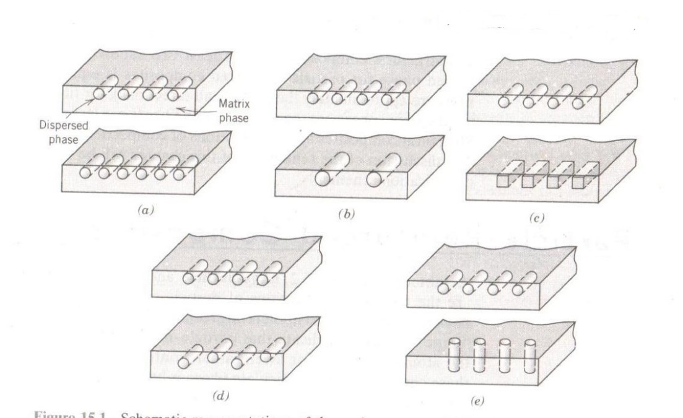

**Fiber reinforced**:

The essential composites are those in which the dispersed phase is in the form of a fiber. The dispersed phase has the geometry of a fiber (large length to diameter ratio). Design goals of fiber reinforced composites often include high strength and /or stiffness on a weight basis. With these composites, an applied load is transmitted to and distributed among the fibers via the matrix phase. On the basis of diameter, fiber reinforcements are classified as whiskers, fibers, or wires.

Fiber orientation and concentration have a significant influence on the strength and other properties of fiber reinforced composites. With respect to orientation, two extremes are possible;

i) a parallel alignment of the longitudinal axis of the fibers in a single direction and

ii) a random alignment. Continuous fibers are generally aligned whereas discontinuous fibers may be aligned randomly oriented or partially oriented. Better overall composite properties are realized when the fiber distribution is uniform.

**Structural**:

Structural composites are combinations of composites and homogeneous materials, the properties of which depend not only on the properties of the constituent materials but also on the geometrical design of the various structural elements. Laminar composites and sandwich panels are two of the most common structural composites.

The properties of laminar composites are virtually isotropic in a 2-D plane. This is made possible with several sheets of a highly anisotropic composite, which are cemented onto one another such that the high strength direction is varied with each successive layer.

Sandwich panels consist of two strong and stiff faces that are separated by a core material or structure. These structures combine relatively high strengths and stiffnesses with low densities.

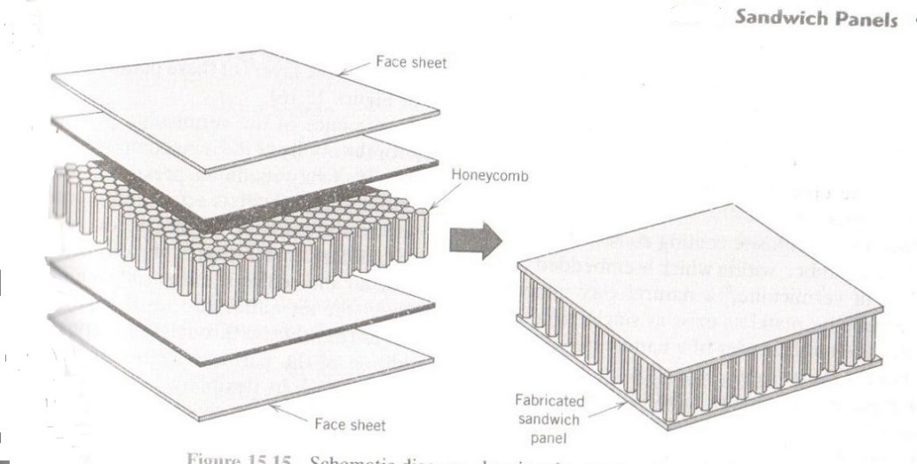

**Influence of length, orientation, concentration, and elastic behavior of fibers**

**Influence of fiber length**

The mechanical characteristics of a fiber-reinforced composite depend not only on the properties of the fiber but also on the degree to which an applied load is transmitted to the fibers by the matrix phase, which in most cases is at least moderately ductile. Significant reinforcement is possible only if the matrix – fiber bond is strong. On the basis of diameter, fiber reinforcements are classified as whiskers, fibers, or wires. Since reinforcement discontinues at the fiber extremities, reinforcement efficiency depends on fiber length. For each fiber – matrix combination, there exists some critical length; the length of continuous fibers dramatically exceeds this critical value, whereas shorter fibers are discontinuous.

For some glass and carbon fiber–matrix combinations, this critical length is on the order of 1 mm, which ranges between 20 and 150 times the fiber diameter.

**Influence of fiber orientation and concentration**

The arrangement or orientation of the fibers relative to one another, the fiber concentration, and the distribution all have a significant influence on the strength and other properties of fiber-reinforced composites. Concerning orientation, two extremes are possible: (1) a parallel alignment of the longitudinal axis of the fibers in a single direction, and (2) a random alignment. Continuous fibers are normally aligned (Figure 6a), whereas discontinuous fibers may be aligned (Figure 6b), randomly oriented (Figure 6c), or partially oriented. Better overall composite properties are realized when the fiber distribution is uniform.

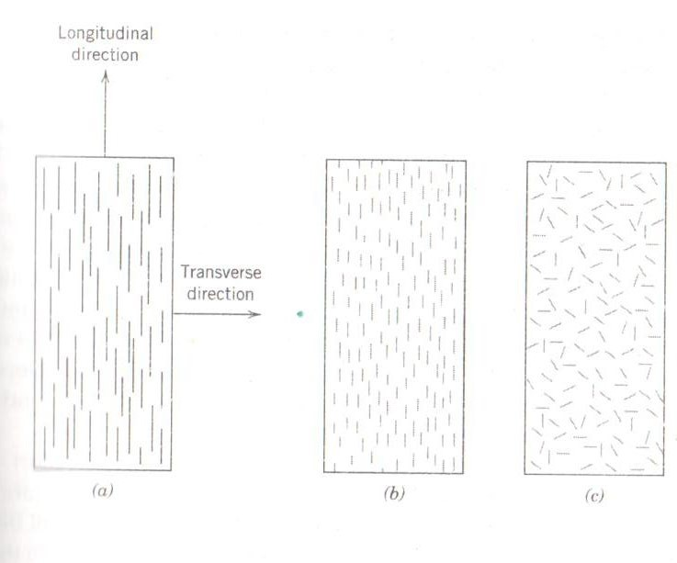

Figure 6a Figure 6b Figure 6c

Fiber arrangements are also crucial relative to composite characteristics. The mechanical properties of continuous and aligned fiber composites are highly anisotropic. In the alignment direction, reinforcement and strength are a maximum; perpendicular to the alignment they are minimum.

For short and discontinuous fibrous composites, the fibers may be either aligned or randomly oriented. Significant strengths and stiffness are possible for aligned short-fiber composites in the longitudinal direction. Despite some limitations on reinforcement efficiency, the properties of randomly oriented short fiber composites are isotropic.

**Elastic Behavior—Longitudinal Loading**

When the load is applied on the composite in the direction of the orientation of continuous fiber, then its modulus of elasticity is equal to the summation of the products of the modulus of elasticity (E) and volume fraction (V) of the respective phases.

*i.e.,* Modulus of elasticity of composite, E = (EV)matrix + (EV)fiber

When the load is applied on the composite perpendicular to the orientation of continuous fiber, the inverse of the modulus of elasticity is equal to the summation of the ratio of volume fraction (V) and modulus of elasticity (E) of the respective phases.

*i.e.,* 1/E = (EV)matrix + (EV)fiber

**Polymer – Matrix Composites**

Polymer-matrix composites (PMCs) consist of a polymer resin as the matrix, with fibers as the reinforcement medium. These materials are used in diverse composite applications, as well as in the largest quantities, due to their room-temperature properties, ease of fabrication, and cost.

Polymer matrix materials:

The matrix materials used in composites are polyesters, vinyl esters, epoxies, polyetheretherketone (PEEK), polyphenylene sulfide (PPS), and polyetherimide (PEI). PEEK, PPS and PEI are the polymeric resins with potential aerospace applications.

The fibers, which are the reinforcing materials generally used are - Glass fibers, carbon fibers or aromatic polyamides (or aramids). Accordingly, they are classified into three categories.

1. Glass Fiber-Reinforced Polymer (GFRP) Composites,
2. Carbon Fiber-Reinforced Polymer (CFRP) Composites, and
3. Aramid Fiber-Reinforced Polymer Composites.

The fiber is embedded in the matrix to make the matrix stronger. Fibre reinforced composites impart two important properties: (i) often stronger than steel (ii) less weight. This means that composites can be used to make automobiles lighter, and thus making them more fuel efficient.

Advantages of polymer composites: Polymer composite materials are preferred to conventional metals and materials for the following advantageous properties;

- Lightweight.

- High strength to weight ratio.

- More durable than conventional materials like steel and aluminum.

- Good corrosion resistance.

- High fatigue strength.

- High-temperature resistance.

Applications:

- Composites of phenolic resins and nylon are used in heat shields for space crafts.

- Automotive and railway applications.

- As the structural material in construction industries.

i) Glass Fibre Reinforced Plastic (GFRP):

Glass Fibre Reinforced Plastic is a typical polymer composite in which the reinforcing material is fiberglass. Its matrix is made by reacting a **polyester with carbon-carbon double bonds** in its backbone and **styrene** - a mix of the styrene and polyester over a mass of glass fibers.

The styrene and double bonds in the polyester react by free radical polymerization to form a cross-linked resin. The glass fiber is trapped inside, where they act as a reinforcement. The matrix adds toughness to the composite, while fibers have good tensile strength. The matrix gives compressional strength to the composite. Fiber reinforced composites are used in applications like car engine components, airplane parts.

ii) Carbon Fiber Reinforced Polymer (CFRP) Composite:

Carbon is a high-performance fiber material that is most commonly used reinforcement in advanced polymer matrix composites. The reasons for this are as follows:

1. Carbon fibers have the highest specific modulus and specific strength of all reinforcing fiber materials.

2. They retain their high tensile modulus and high strength at elevated temperatures; high-temperature oxidation, however, may be a problem.

3. At room temperature, carbon fibers are not affected by moisture or a wide variety of solvents, acids, and bases.

4. These fibers exhibit a diversity of physical and mechanical characteristics, allowing composites incorporating these fibers to have specific engineered properties.

5. Fiber and composite manufacturing processes have been developed that are relatively inexpensive and cost-effective.

Use of the term “carbon fiber” may seem perplexing since carbon is an element. Carbon fibers are not totally crystalline, but are composed of both graphitic and noncrystalline regions; these areas of non-crystallinity are devoid of the three-dimensional ordered arrangement of hexagonal carbon networks that is characteristic of graphite. Manufacturing techniques for producing carbon fibers are relatively complex and will not be discussed. However, three different organic precursor materials are used: rayon, polyacrylonitrile (PAN), and pitch. Processing technique will vary from precursor to precursor, as will also the resultant fiber characteristics.

Carbon-reinforced polymer composites are currently being utilized extensively in sports and recreational equipment (fishing rods, golf clubs), filament-wound rocket motor cases, pressure vessels, and aircraft structural components—both military and commercial, fixed wing and helicopters (e.g., as a wing, body, stabilizer, and rudder components).

iii) Aramid Fiber-Reinforced Polymer Composite:

Aramid fibers are high-strength, high-modulus materials that were introduced in the early 1970s. They are especially desirable for their outstanding strength-to-weight ratios, which are superior to metals. Chemically, this group of materials is known as poly(paraphenylene terephthalamide). There are some aramid materials; trade names for two of the most common are Kevlar™ and Nomex™.

Kevlar composites:

Kevlar is an aromatic polyimide (or aramid). The chemical composition of Kevlar is poly(para phenyleneterephthalamide). They belong to the family of nylons. Common nylons, such as nylon-6,6 do not have very good structural properties, so the incorporation of para-aramids improve the properties. The aramid ring gives Kevlar its thermal stability, while the para structure gives it high strength and modulus. Kevlar is used as matrix material whereas many fibers like carbon fiber or glass fiber are used as the reinforcing agent.

Advantages:

- Lightweight, high strength, Thermally Stable

- Resistant to impact and abrasion damage. It can be used as a protective layer on graphite laminates.

- Can be mixed with graphite to provide damage resistance and to prevent failure.

Disadvantages:

- Fibers themselves absorb moisture, so Kevlar composites are more sensitive to the environment than glass or graphite composites.

- Poor compression resistance.